Developing the Resource Plan

Role Requirements

Managerial Positions
Our managerial positions require the following skills for the following reasons:
- Leadership: for team management.
- Empathy: to gain respect in their teams, in turn leading to better leadership and a better environment.
- Excellent communication skills: to effectively communicate with other managers throughout the project, and of course their own team(s).
- Supportive: to support ideas of everyone in meetings allows for better cohesion and more ideas to be generated in the long run.
- Knowledgeable: they must be knowledgeable in their role, and of the project in order to make informed decisions based on information that they are provided.
- Time management: this is essential when scheduling.
- Interpersonal skills: these skills are crucial in conjunction with their communication skills.

Public Relations
- Accountable: they should be accountable for what they allow to be seen by the public.
- Persuasive skills: In conjunction with their communication skills, must be used to spin negatives as positives and cater the desires of the public.
- Excellent communication skills: For obvious use in well articulated articles and promotional materials.
- Resourcefulness (able to get information): they must be able to gather information about not only our project and team, but competing teams and in conjunction with their creative skills, promote our team as the more identifiable.
- Creative: see “resourcefulness”.
- Organised: promotional events are held on certain dates, resulting in very strict deadlines for their work.
- Analytical: must be able to critically analyse other persons works and see how they would be interpreted by the public, and why.

Quality Checker
- Methodical approach: to attain a high level of quality, there is generally a standard “test early, test often” mindset. This sort of often testing requires a methodical approach, as to not allow for invalid testing results to arise.
- Critical thinking: must be able to see weakness such as “it’s not a bug, it’s a feature”, and apply a process of thinking to solve the problem, suggesting a better solution.
- Problem solving: see “Critical thinking”.
- Process knowledge: they must have knowledge of the design and development processes that are being used inside the organisation.
- Attention to detail: this is essential as to have a product of the upmost quality, all details must be accounted for and qualified.

Procurement Officer
- Critical thinking: comparing deals and finding how a better deal could fit the solution is a simple example of how critical thinking is used in this role.
- Excellent communication skills: in conjunction with their negotiation and persuasive skills, the right candidate(s) should be able to come up with the best deal from multiple sources.
- Negotiation: see “Excellent communication skills”.
- Management knowledge: a need to understand how management handles procurement, and what kind of deals fit their needs and ours.
- Legal knowledge: required to stay in line with the laws of procurement (i.e., don’t be bribed).
- Persuasion: see “Excellent communication skills”.

Social Media
- Experience developing a social media strategy: an experienced social media moderator must be able to create a strategy with maximum reach to the right target audience. The strategies used to achieve that strategy are generally known to be creative and known to experience personnel.
- Empathetic: due to this being a customer facing position, it is important for customers to feel as though the organisation is on their side, cheering for them at their level.
- Creative: see “Experience developing a social media strategy”.
- Excellent communication skills: required as to not bring an unprofessional look to the team.

Development Teams
- Empathy: teams that empathise with each other feel more comfortable providing their ideas to the team, therefore increasing the number of solutions brought from different background.
- Communication skills: as a team environment, communication is key. If something isn’t being completed due to a lack of knowledge, or it is simply a larger task than expected, the simple communications that are often overlooked can keep the situation from snowballing and delaying the project.
- Previous TEAM experience: previous team experience desirable to enforce the communication and empathy that makes an exceptional team work so well.

Role Responsibilities

CLAYYONNNNN!

Can you please make “Responsibility Assignment Matrix.xlsx” fit on this page? ☺

Reporting Relationships

Resource Histogram

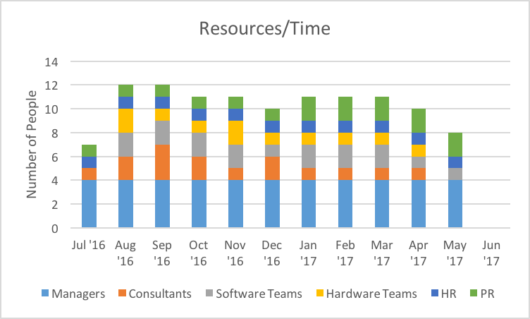

Acquiring the Project Team
Due to the short contract of employment that the project team will be met with, to hire the talent that we desire we have laid out several incentives that in conjunction with a larger, short-term salary, we believe makes us very competitive.

Employee Incentives

Recruitment
We will make it well known on job listings that we can offer a national relocation stipend and telecommuting options once their contract has commenced. Applicants that are able to progress into an in-person interview will be notified that due to their duration of employment, a signing bonus is offered for peace of mind, as is a hardware stipend to purchase a laptop for their work. Not only are these “perks” competitive, but their salary is required to greater average, again due to the insecurity of their job.

Retention
Upon making it onto the project, we push for teams to take training to encourage their interpersonal and team-work skills. It’s incentivised that those teams that work well together, completing tasks before deadlines, being loyal, appropriate, and working to get the job done, will be rewarded with bonuses of varying proportion. We plan to utilise in-house lunches, so that teams can eat together, allowing them to further immerse themselves and discuss their work, while also allowing them to work while they eat. On top of everything else, we would like to extend personal development training to employees that are seen to earn it. Whether it’s books they want to read to improve a technical skill, or a training course from a top-provider, we feel that if your team has less to worry about, they can focus on the task that they need to achieve.

